### PENJELASAN REGRESI ,CLASIFICATION, CLUSTERING

<https://www.youtube.com/watch?v=wuOzuToz65c>

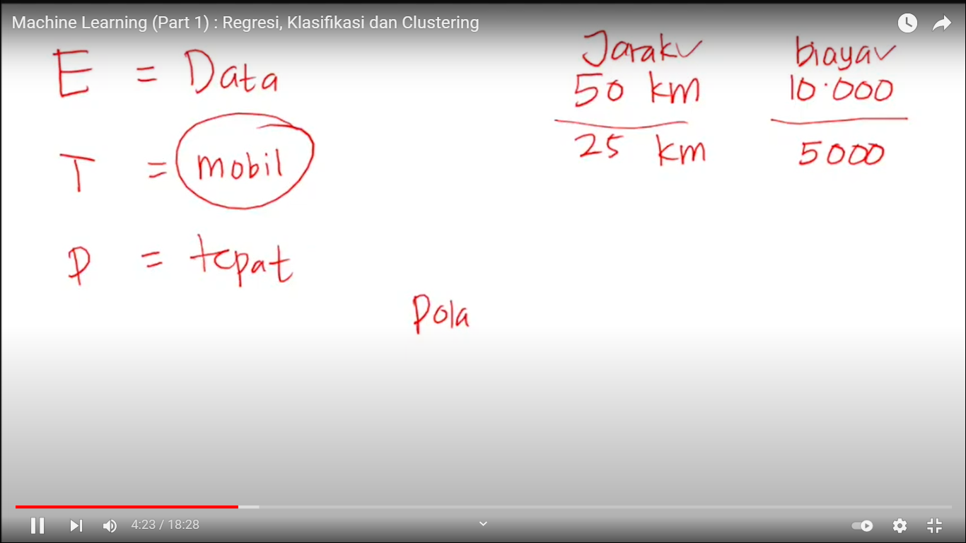

# REGRESI

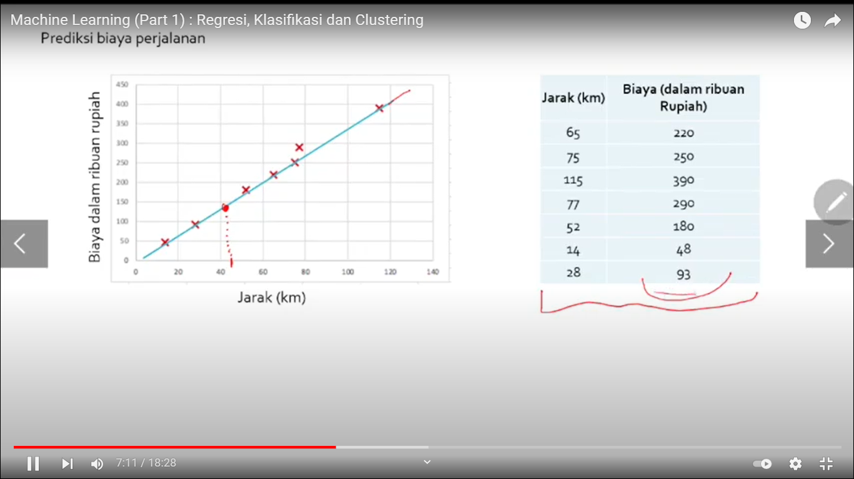

# KLASIFIKASI

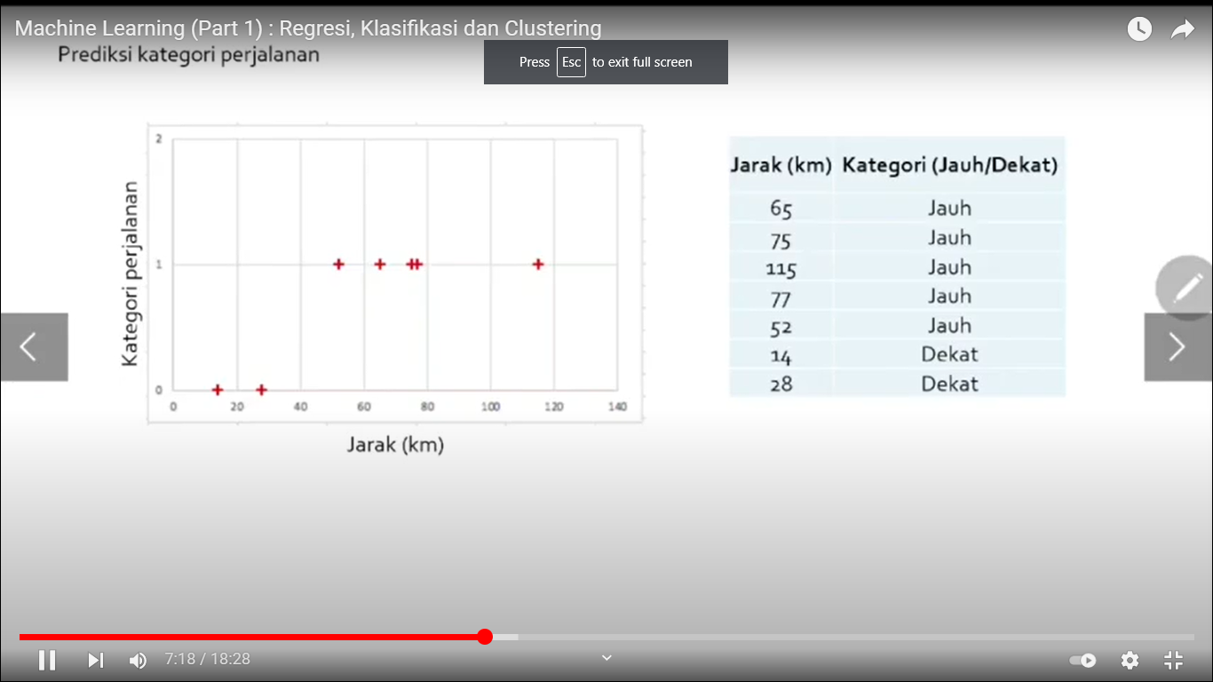

# CLUSTERING

